SOP Name | Version | Date | Author | L1 | L2 | L3 | L4
Split/Combine Booking-South Korea | 1 | 2026.04.27 | LTL020/  VFH003 | Order To Cash | Order Management | Amend Order | Amend Order - Ocean (As-Is)

Task status:
- Business Unit
- KMS
- Booked by
- Price Owner
- Product delivery
- DG/ Reefer/OOG/ shipment or not
- Current container type and volume:
- Container number:
- Detail match(BBY/PO/Commodity/NAC/Contact/POL/POD/Discharge/all vessel/service mode/SC)

Split
- Open case in CM & Check the request
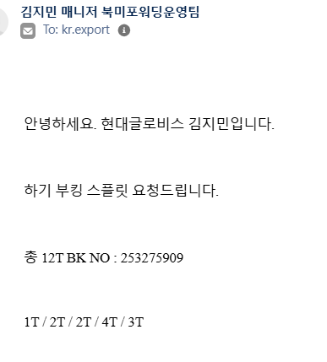
- Check if DG shipment
- Yes, out of AI scope, please do not generate AI.
- No, Go to step 3.
- Update the Reason for case with below detail
Type: Booking
Sub Type: Amend Booking Details
Reason For Case: Split/Combine Booking
- Check whether this booking has passed the 1st KMS
  - Check if the ETD is>=7 days from current date
- If >=7 days, please go to 5.
- If < 7 days, please move to 4.2
  - Check the KMS timeline from weekly timetable
Select correct String/Load port/Vessel and check the 1st KMS timeline
- ➢ If passed, assign case to MIG for DTCX/OTCX EXP, FO for ICX and KCEC-AUTO, KCEC-TECH.
- ➢ If not passed, pls move to 5.

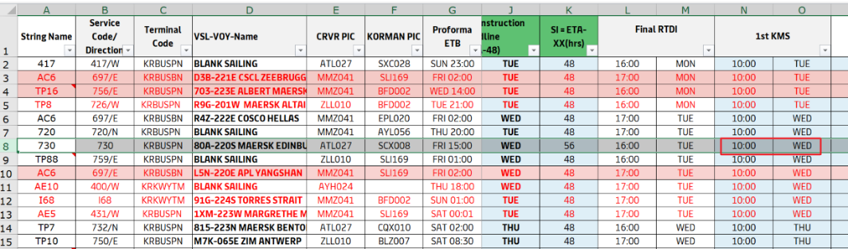

- Check the customer if it’s KC customer, KC customer PO list as below.
Price owner
SAMSUNG MEDISON CO LTD (41800216362)
SAMSUNG SDS (41800185557)
SAMSUNG ELECTRONICS LOGITECH (41800080865)
SAMSUNG SDI MAGYARORSZAG ZRT (11600033725)
SAMSUNG SDS GLOBAL SCL POLAND SP.Z O.O. (12300086718)
SAMSUNG C AND T CORPORATION (41800078548)
SAMSUNG SDS TPL CO LTD (41800231764)
SAMSUNG SDI CO LTD (418504030)
SAMSUNG C&T DEUTSCHLAND GMBH (11300084870)
SAMSUNG ELECTRONICS HOME APPLIANCE AMERICA (33102560511)
LX PANTOS CO.,LTD (418508246)
Pantos ICR(41800900321)
LX PANTOS CO LIMITED(41800051593)
LG CHEMICAL LTD (418S14010)
LG ELECTRONICS INC(418671013GS)
LG ENERGY SOLUTION(41800907871)
LX PANTOS (2PL)(41800944410 )
GLOVIS AMERICA INC (33101018803)
HYUNDAI MOTOR CO (418770268HD)
HYUNDAI GLOVIS CO, LTD（418S29454）
  - Yes, go to step 6;
  - No, not KC customer, reject customer request with below template.
안녕하세요, 고객님,
머스크 수출 고객지원팀입니다.

죄송합니다만 매뉴얼로 부킹 Split 진행이 불가함을 양해 부탁드립니다. 필요 시 SI 제출 단계에서 BL Split 요청을 통해 진행해 주시기 바랍니다.

부킹 Split이 꼭 필요하신 경우, 웹에서 신규 부킹 및 기존 부킹 댓수 정정을 제출하여 진행해 주시기 바랍니다.
Spot 부킹의 경우 컨테이너 삭제 시 캔슬 또는 노쇼비용이 발생되오니 이 점 주의하시어 진행 부탁드립니다

감사합니다.
- Customer mentioned container qty if match with system.
- Yes, go to step 7.
- No, use below template double check with customer, then go to step 7.
안녕하세요, 고객님,
머스크 수출 고객지원팀입니다.

Booking Number: XXXXX
해당 부킹은 시스템상 총 수량 XX로 확인되었습니다. 정확한 컨테이너 수량 재 확인 부탁드립니다.

감사합니다.
- Split the BKG as per customer request.
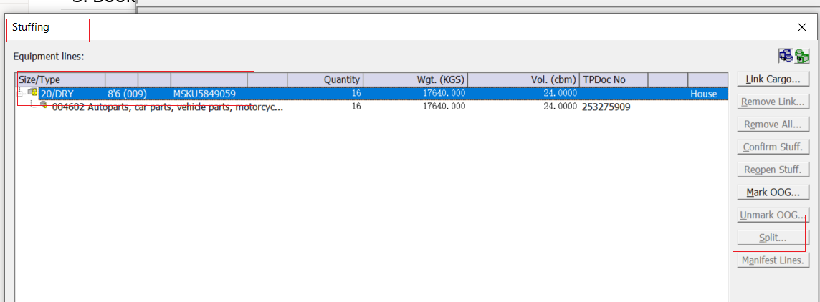
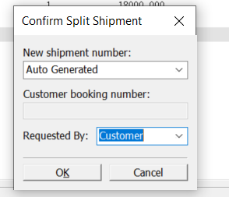

Splited BKG number will pop-up. Confirm both booking and Inform customer the booking number with container volume.
안녕하세요, 고객님,
머스크 수출 고객지원팀입니다.

Booking Number: xx – 20dry*1
Booking Number: xx – 20dry*2
요청하신대로 부킹 스플릿 처리 완료하였사오니, 고객님 메일로 송부드린 부킹 시트를 참고해 주시기 바랍니다.

감사합니다.

Combine
- Open case in CM & Check the request
- Check if DG shipment
- Yes, out of AI scope, please do not generate AI.
- No, Go to step 3.
- Update the Reason for case with below detail
Type: Booking
Sub Type: Amend Booking Details
Reason For Case: Split/Combine Booking
- Check whether this booking has passed the 1st KMS
  - Check if the ETD is>=7 days from current date
- If >=7 days, please go to 5.
- If < 7 days, please move to 4.2
  - Check the KMS timeline from weekly timetable
Select correct String/Load port/Vessel and check the 1st KMS timeline
- ➢ If passed, assign case to MIG for DTCX/OTCX EXP, FO for ICX and KCEC-AUTO, KCEC-TECH.
- ➢ If not passed, pls move to 5.

- Check the customer if it’s KC customer, KC customer PO list as below.
Price owner
SAMSUNG MEDISON CO LTD (41800216362)
SAMSUNG SDS (41800185557)
SAMSUNG ELECTRONICS LOGITECH (41800080865)
SAMSUNG SDI MAGYARORSZAG ZRT (11600033725)
SAMSUNG SDS GLOBAL SCL POLAND SP.Z O.O. (12300086718)
SAMSUNG C AND T CORPORATION (41800078548)
SAMSUNG SDS TPL CO LTD (41800231764)
SAMSUNG SDI CO LTD (418504030)
SAMSUNG C&T DEUTSCHLAND GMBH (11300084870)
SAMSUNG ELECTRONICS HOME APPLIANCE AMERICA (33102560511)
LX PANTOS CO.,LTD (418508246)
Pantos ICR(41800900321)
LX PANTOS CO LIMITED(41800051593)
LG CHEMICAL LTD (418S14010)
LG ELECTRONICS INC(418671013GS)
LG ENERGY SOLUTION(41800907871)
LX PANTOS (2PL)(41800944410 )
GLOVIS AMERICA INC (33101018803)
HYUNDAI MOTOR CO (418770268HD)
HYUNDAI GLOVIS CO, LTD（418S29454）
  - Yes, go to step 6;
  - No, not KC customer, reject customer request.
안녕하세요, 고객님,
머스크 수출 고객지원팀입니다.

죄송합니다만 매뉴얼로 부킹 Combine 진행이 불가함을 양해 부탁드립니다. 필요 시 SI 제출 단계에서 BL Combine 요청을 통해 진행해 주시기 바랍니다.

부킹 Combine이 필요하실 경우, 웹에서 A 부킹의 대수를 증량한 뒤 B 부킹을 취소 요청해 주시기 바랍니다.
Spot 부킹의 경우 부킹 취소 시 캔슬 또는 노쇼비용이 발생되오니 이 점 주의하시어 진행 부탁드립니다

감사합니다.
- Check if the BKG details to be combined are the same.
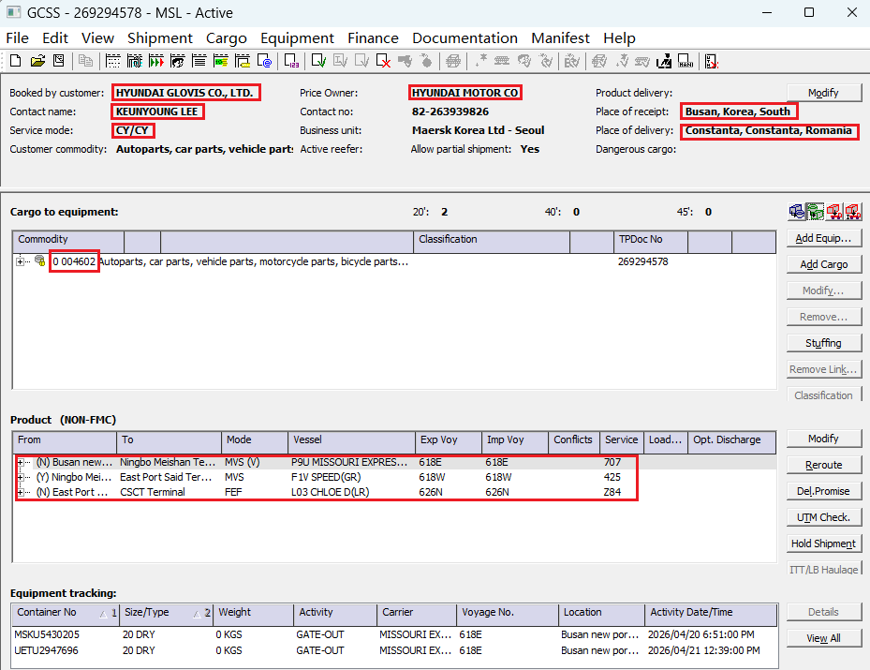
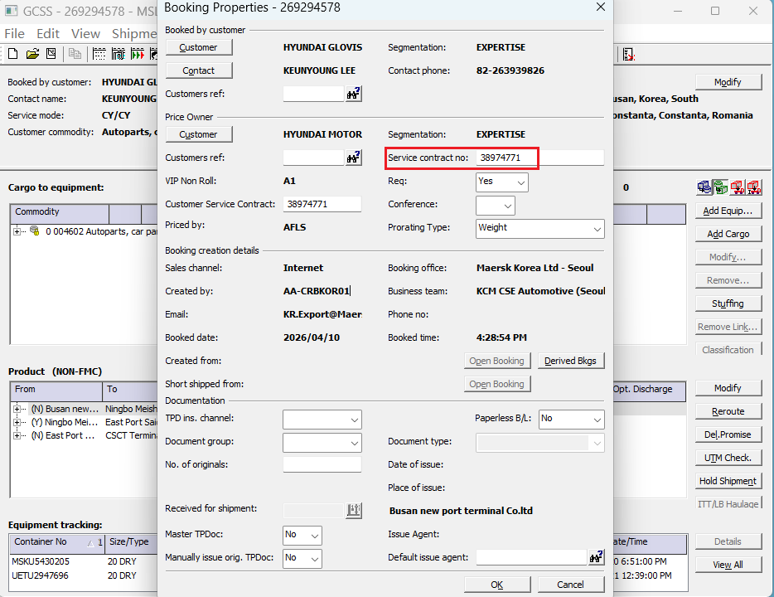
- Yes, go to step 7.
- No, use below template double check with customer, then go to step 7.
안녕하세요, 고객님,
머스크 수출 고객지원팀입니다.

Booking Number: XXXXX/XXX
컴바인 대상인 하기 디테일 상이하여 컴바인 처리가 불가하오니 참고 바랍니다.
디테일: Booking A:XXX / Booking B: XXX

감사합니다.
- Create ISR to FO, check all BKG if have same VP and Accelerate. (Need assign ISR to correct PIC)
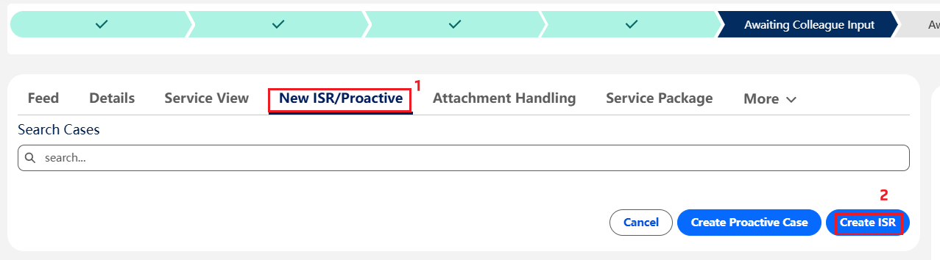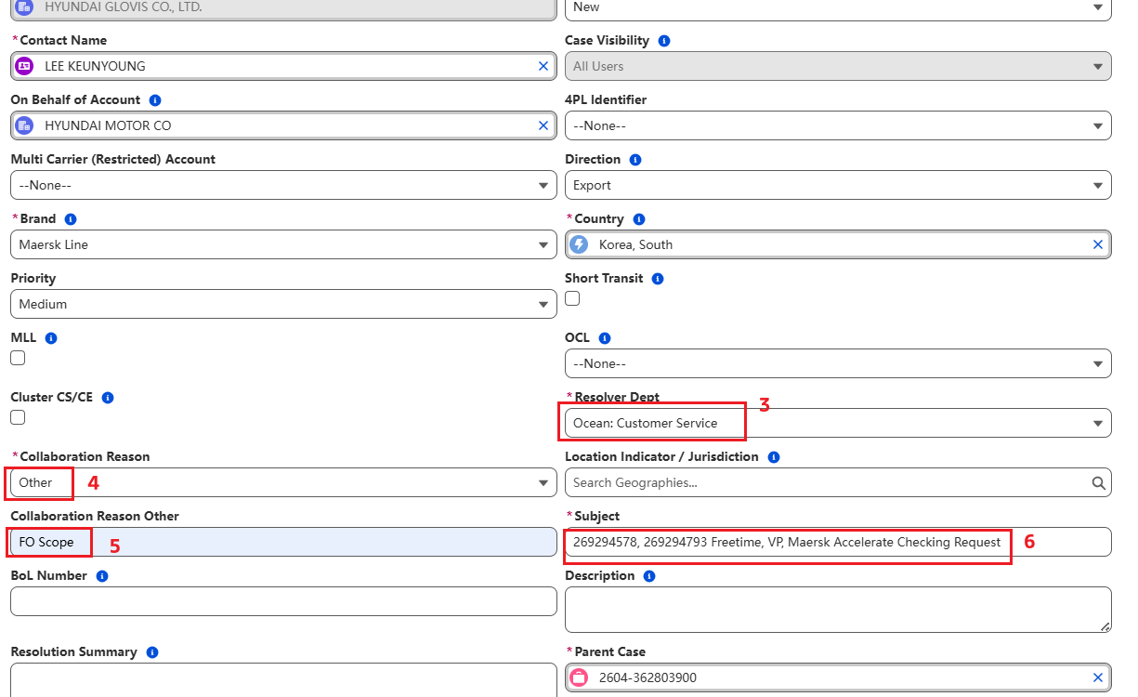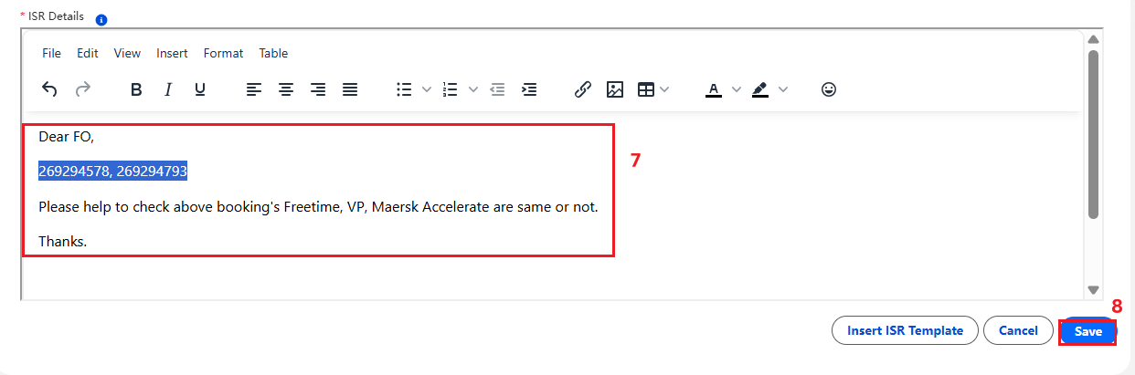
ISR Details:
Dear FO,

Booking number: xxxxxx /xxxxx
Please help to check above booking’s Freetime,VP, Maesrsk Accelerate are same or not.
Customer request combine BKG.

Thanks
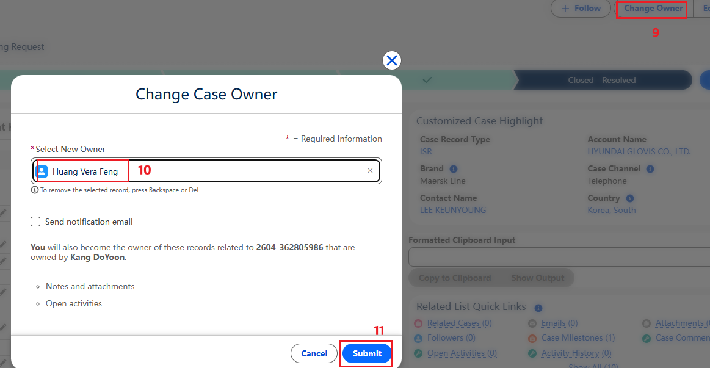
When Price owner = below list, use HD link check PIC
GLOVIS AMERICA INC (33101018803)
HYUNDAI MOTOR CO (418770268HD)
HYUNDAI GLOVIS CO, LTD（418S29454）

HD: Auto PIC list (Web 视图)
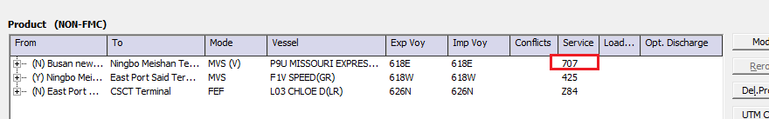
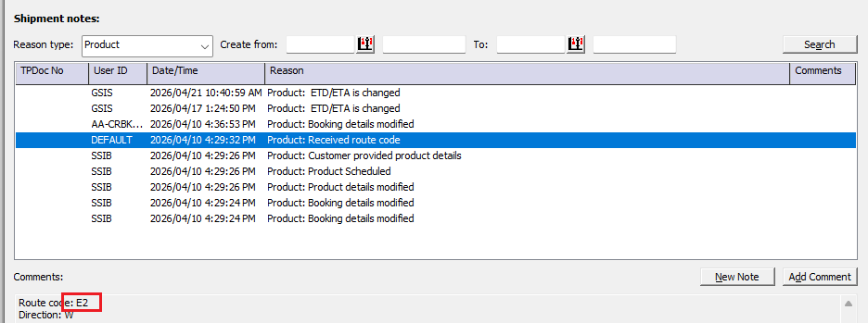
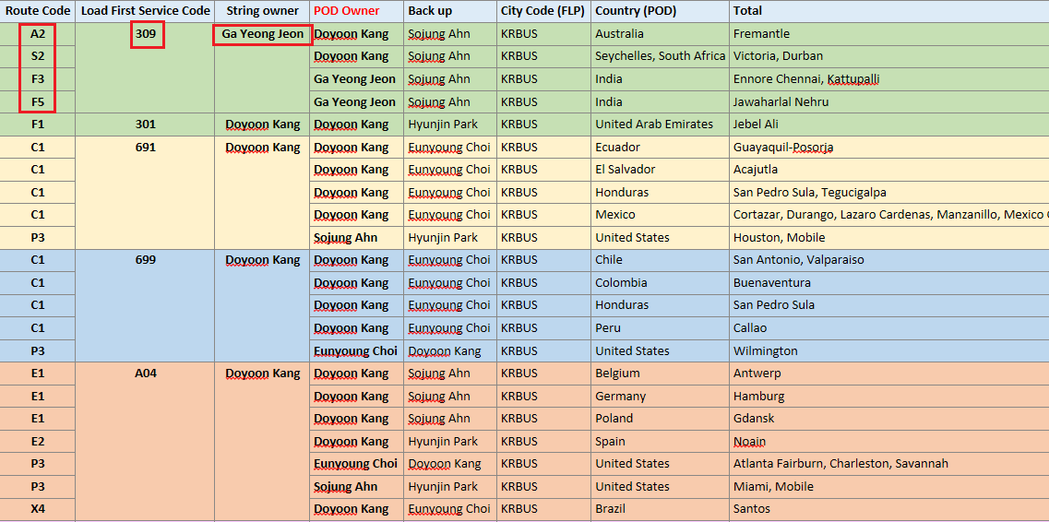
When Price Owner= below list, use PANTOS/SS list check PIC

Price owner
SAMSUNG MEDISON CO LTD (41800216362)
SAMSUNG SDS (41800185557)
SAMSUNG ELECTRONICS LOGITECH (41800080865)
SAMSUNG SDI MAGYARORSZAG ZRT (11600033725)
SAMSUNG SDS GLOBAL SCL POLAND SP.Z O.O. (12300086718)
SAMSUNG C AND T CORPORATION (41800078548)
SAMSUNG SDS TPL CO LTD (41800231764)
SAMSUNG SDI CO LTD (418504030)
SAMSUNG C&T DEUTSCHLAND GMBH (11300084870)
SAMSUNG ELECTRONICS HOME APPLIANCE AMERICA (33102560511)
LX PANTOS CO.,LTD (418508246)
Pantos ICR(41800900321)
LX PANTOS CO LIMITED(41800051593)
LG CHEMICAL LTD (418S14010)
LG ELECTRONICS INC(418671013GS)
LG ENERGY SOLUTION(41800907871)
LX PANTOS (2PL)(41800944410 )
PANTOS/SS: E-goods PIC list (Web 视图)
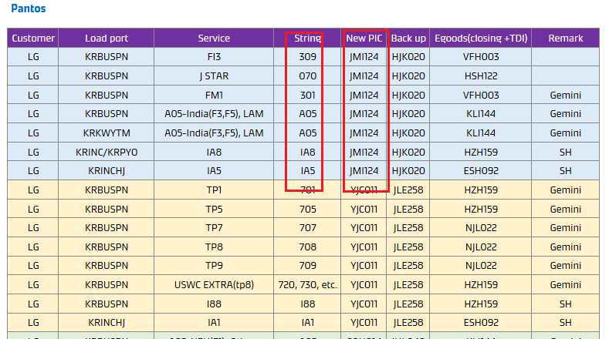
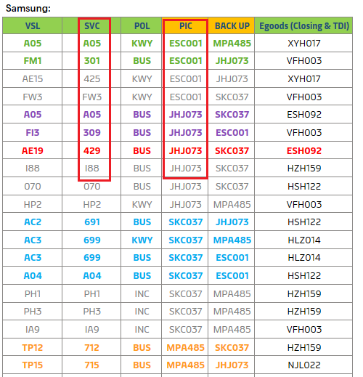

- After FO confirmed we can process Combine. Follow below steps to combine.
(Add containers for the BKG number which customer want to keep, Cancel the booking number which customer do not use)

Add container
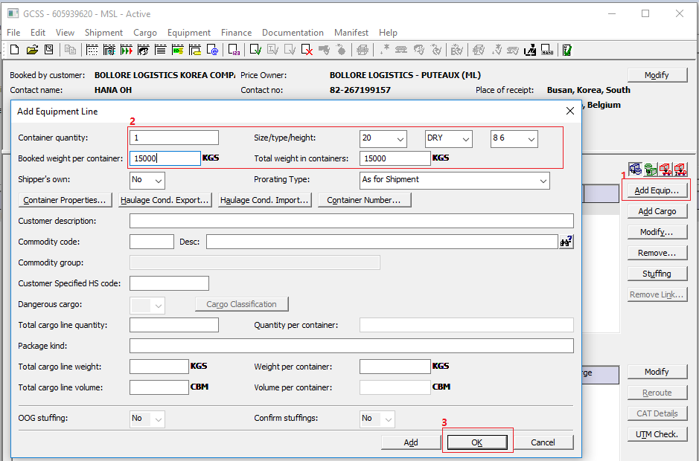
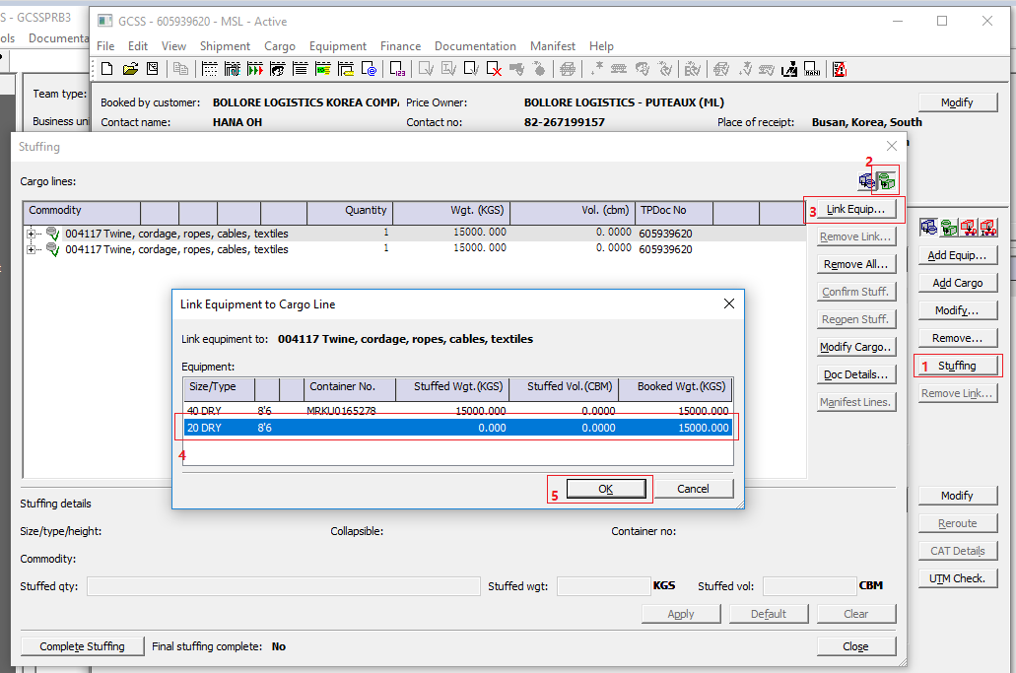

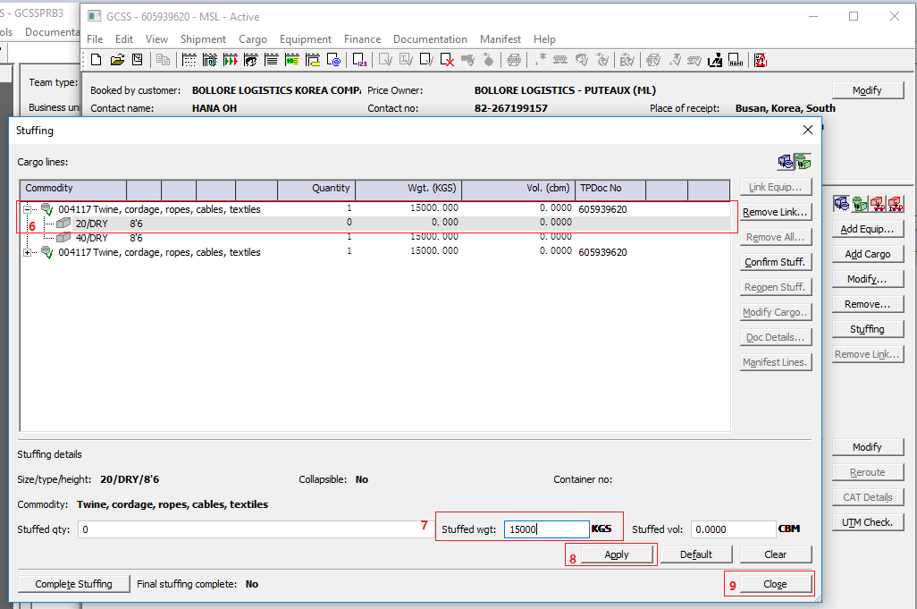

Resend haulage:
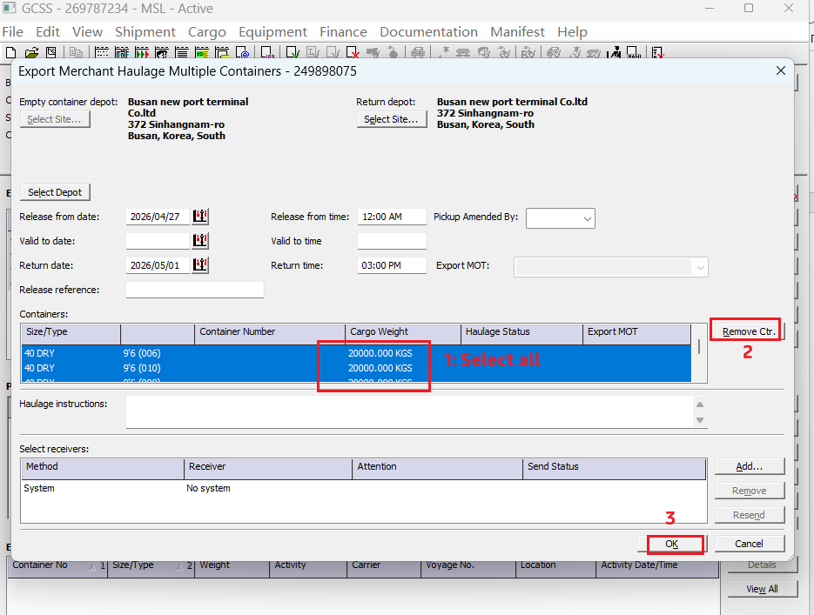
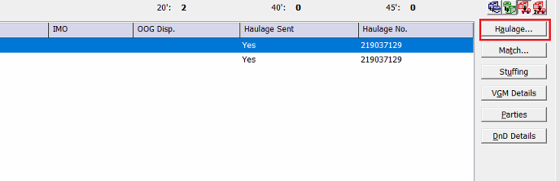
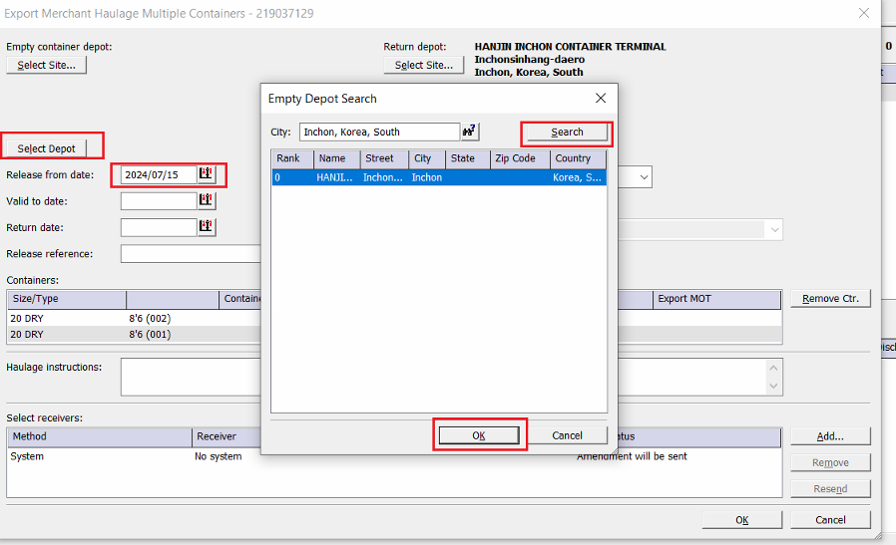
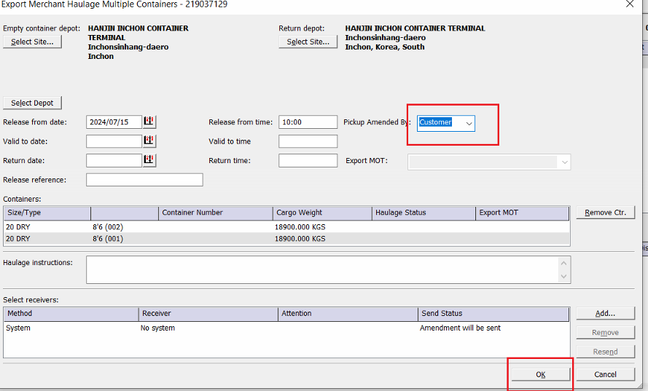

Click “Check UTM” and check UTM result
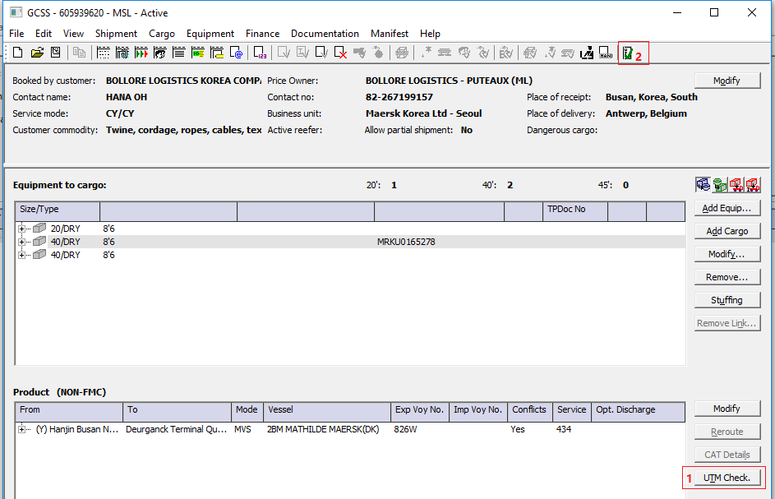
- UTM ok, go to step 9.
- UTM reject, add standard note. Ask PIC close UTM task, then go to step 9.
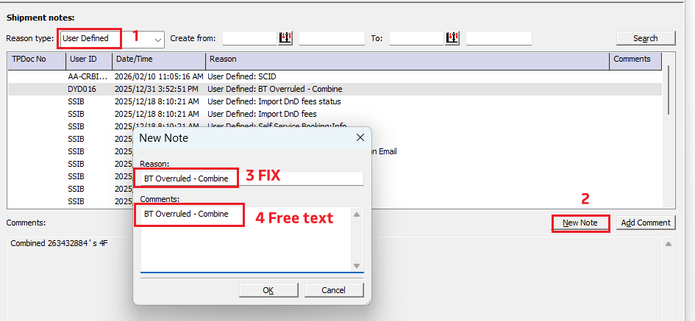

Confirm BKG to customer

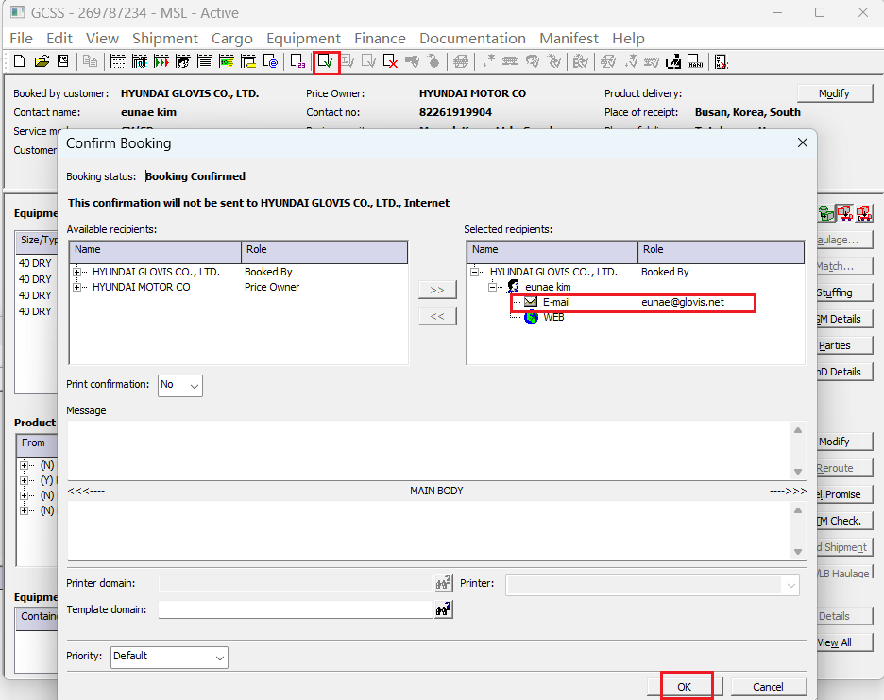

Cancel the Booking B:
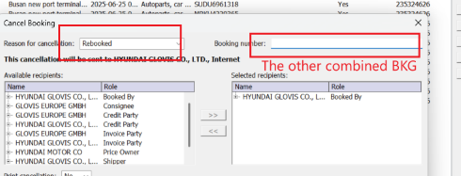

- Reply customer combine done.
안녕하세요, 고객님,
머스크 수출 고객지원팀입니다.

Booking Number: XXXXX/XXX
요청하신대로 컴바인 처리 완료되었습니다. 송부드린 부킹 시트 확인 부탁드립니다.

감사합니다.

